WEBPROG Midterms Project Resource Documentation

Passing the HTML and CSS Validation
HTML Validator – https://validator.w3.org/nu/?doc=https%3A%2F%2Fsaquianzon.github.io%2FWEBPROG-SF231-Personal-Website%2Fhome%2F
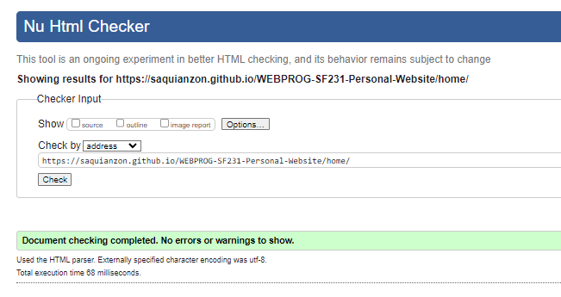
CSS Validator – https://jigsaw.w3.org/css-validator/validator?uri=https%3A%2F%2Fsaquianzon.github.io%2FWEBPROG-SF231-Personal-Website%2Fhome%2F&profile=css3svg&usermedium=all&warning=1&vextwarning=&lang=en
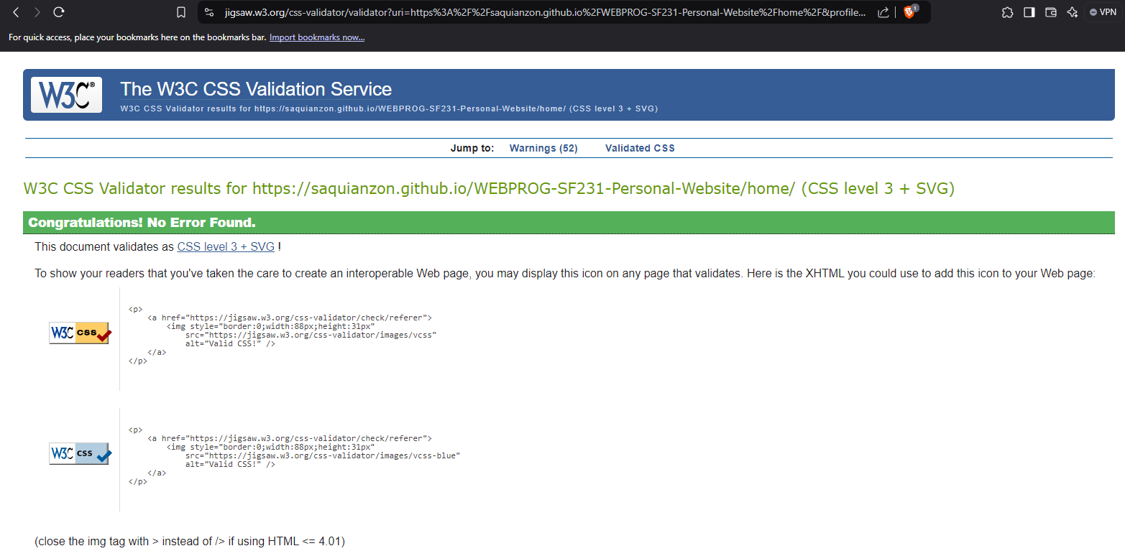
Website Templates source:
https://www.w3schools.com/w3css/w3css_templates.asp
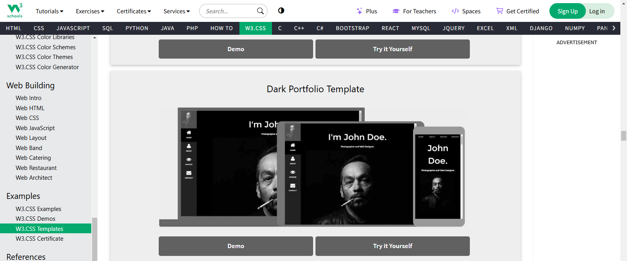

Main Template used for the Website
https://www.w3schools.com/w3css/tryit.asp?filename=tryw3css_templates_dark_portfolio&stacked=h
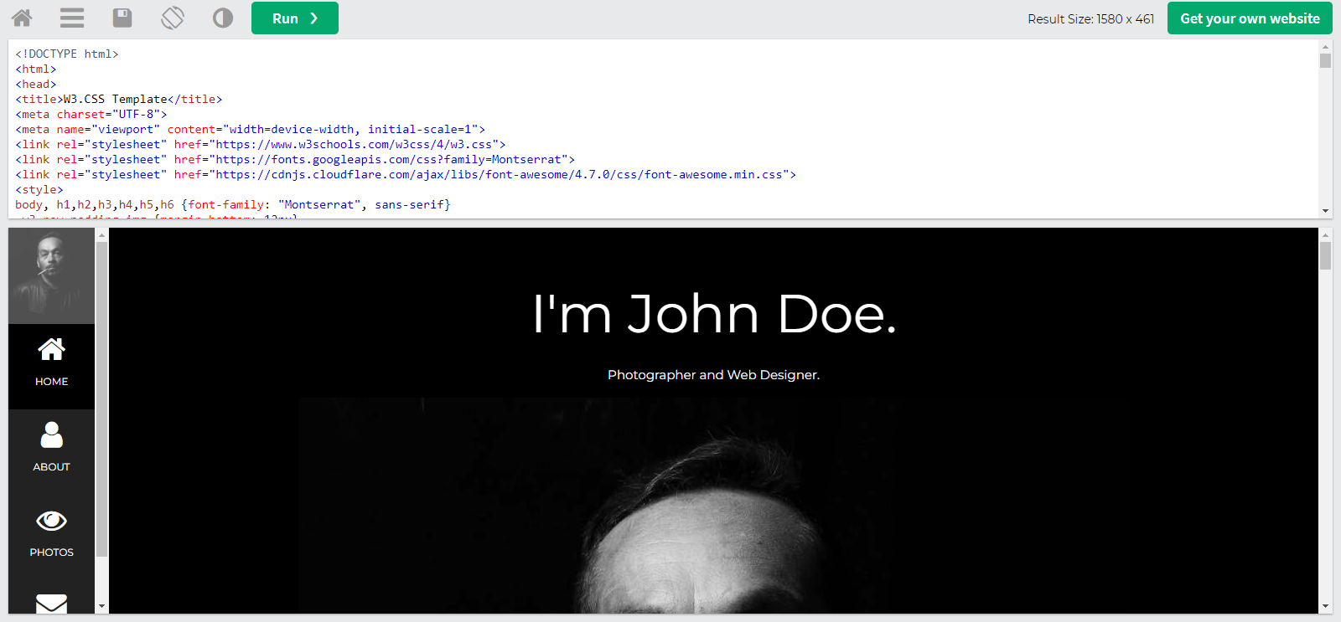

Additional Resources taken from the main template, including CSS
Main CSS - https://www.w3schools.com/w3css/4/w3.css
Text Font - https://fonts.googleapis.com/css?family=Montserrat
Icons - https://cdnjs.cloudflare.com/ajax/libs/font-awesome/4.7.0/css/font-awesome.min.css

HTML Online Compiler (to avoid countless commits piling up in my repository)
https://onecompiler.com/
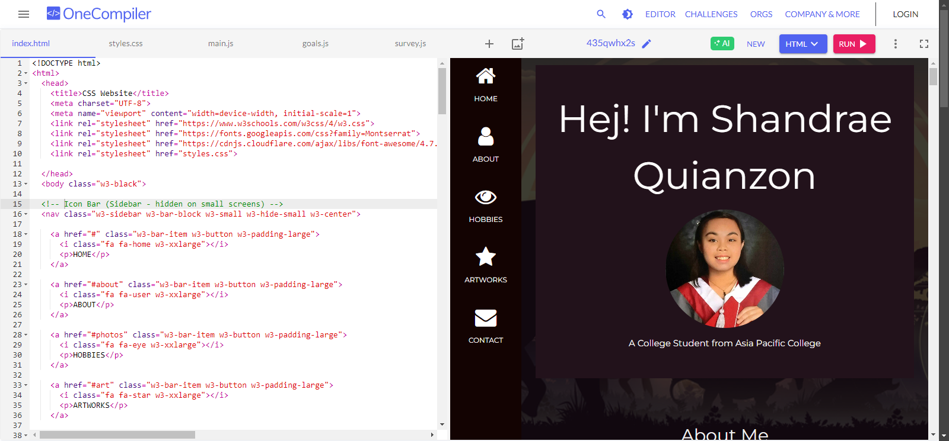

Main Guide for the Coding and Syntax (greatly helped design my website)
https://www.w3schools.com/
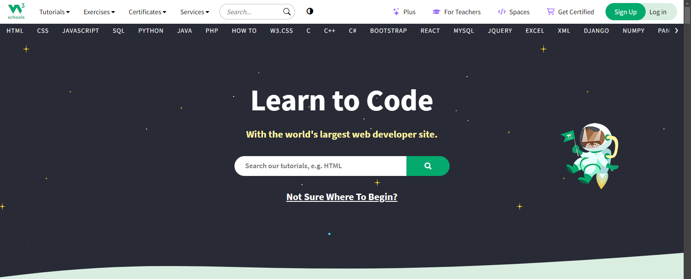

Inspiration/References for the Website
Website inspiration
www.jw.org

By a Content Creator and Artist named Louixie (for the gallery image layout) https://toyhou.se/Louixie
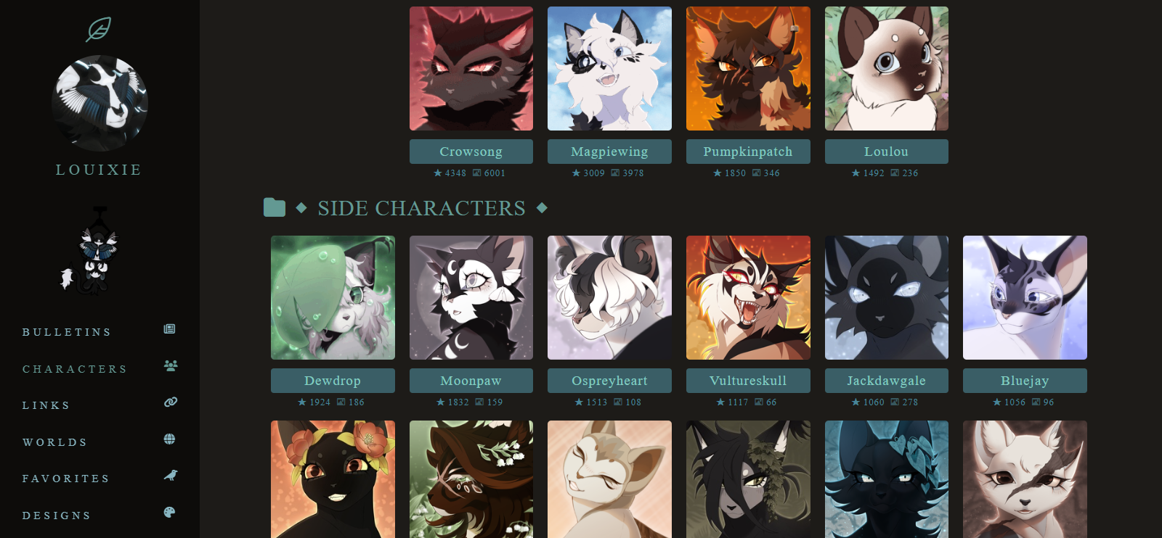
Another website template by W3schools (for image interaction) https://www.w3schools.com/w3css/tryit.asp?filename=tryw3css_templates_startup
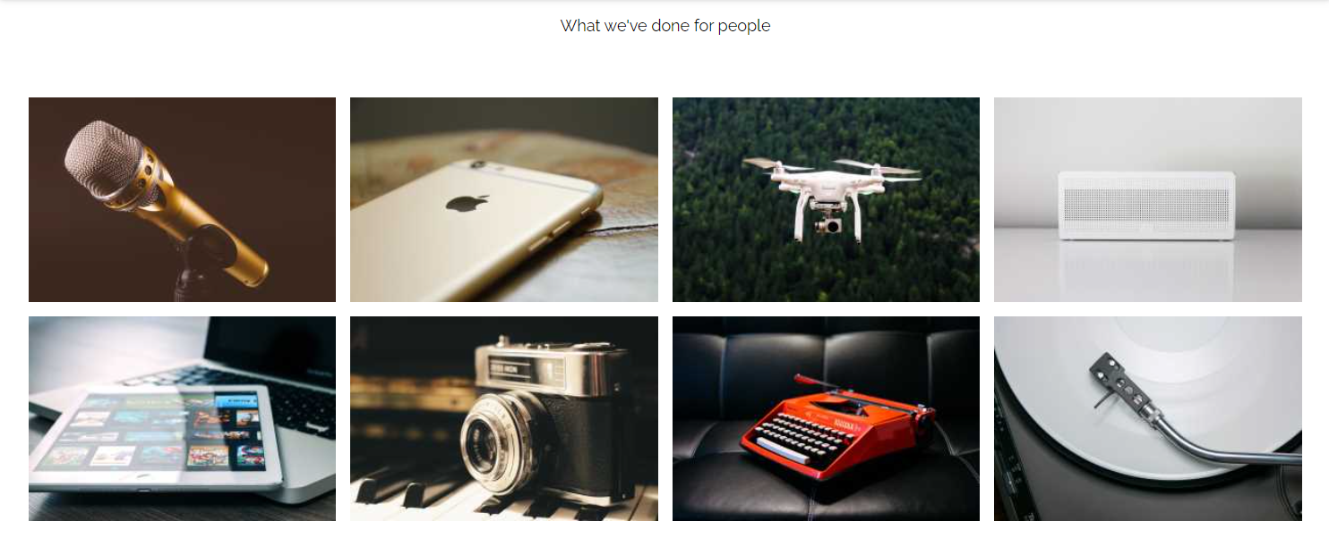

AI Tools used
ChatGPT - https://chatgpt.com/


Images and Videos Used for the Website

Background Image
https://www.wallpaperflare.com/jurassic-park-jurassic-world-sky-digital-composite-silhouette-wallpaper-zwlm

Preaching Work for Goals in Life/Dreams
www.jw.org
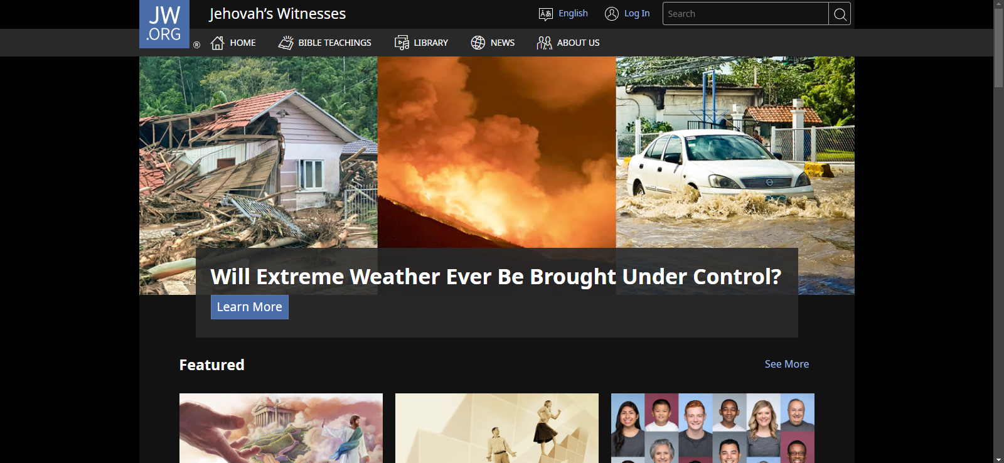

Guardians of Ga’Hoole: The Siege Novel
https://www.goodreads.com/book/show/7027.The_Siege
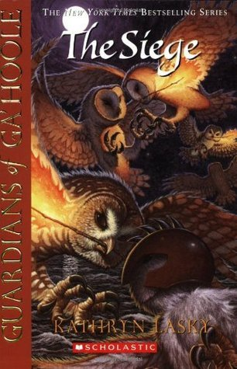
Jurassic Park Fan Poster Design by Seventh Voyage
(Original Poster) - https://www.instagram.com/p/CUQMeGZpSnP/
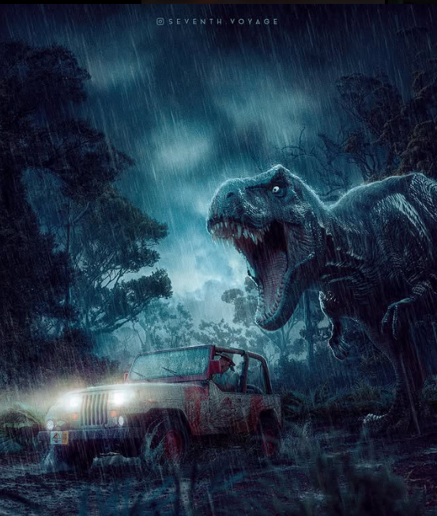
(YouTube Video Version) - https://www.youtube.com/watch?v=1-4xcoT5c-o&t=108s
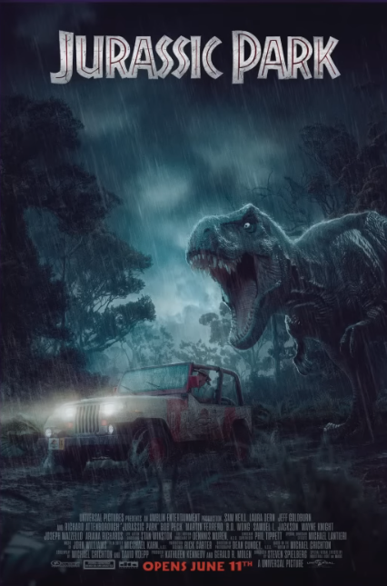
The Figure from Roblox DOORS
(Doors Animation by Jeny_Punker) https://www.youtube.com/watch?v=dcPUujoMoPI
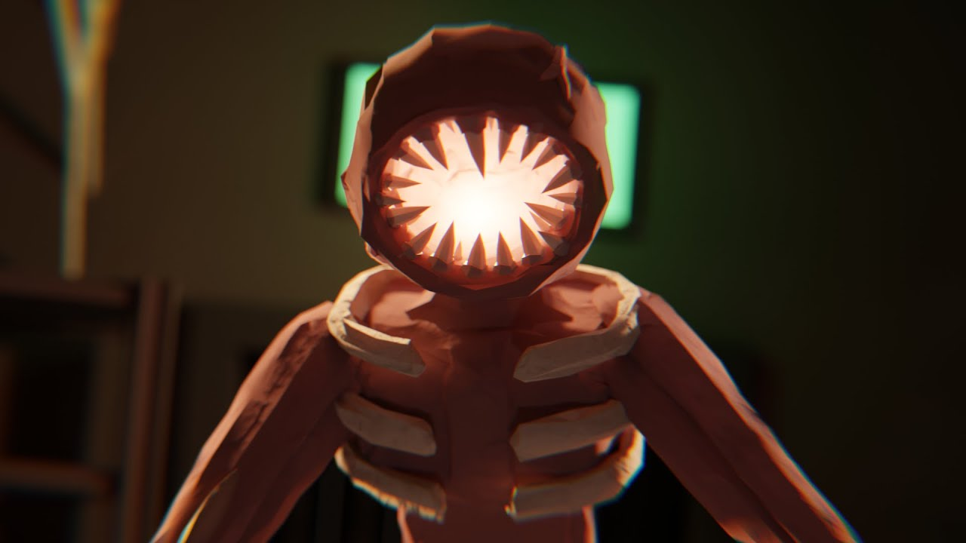
Video Clips used for the GIF (Compiled and edited by me)

Leap of Faith Scene – Spider-man: Into the Spiderverse
https://www.youtube.com/watch?v=yoS74R-qKIY
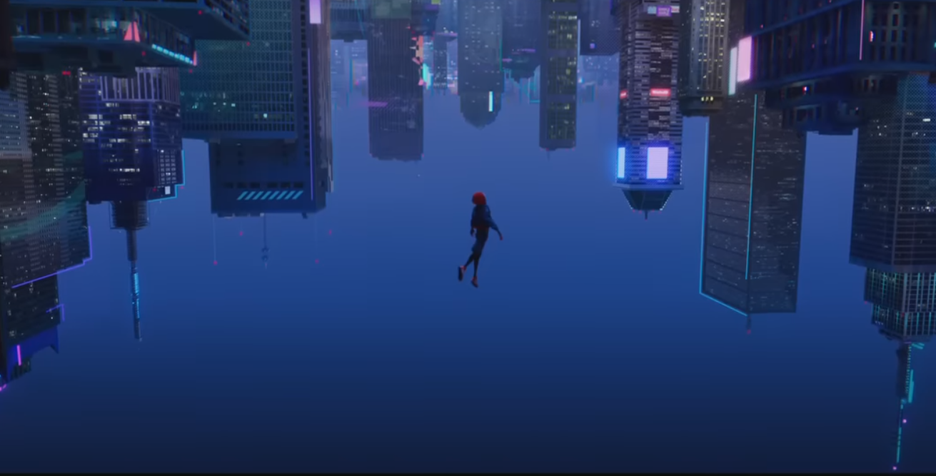
Wanted - Animator vs Animation 9 by Alan Becker
https://www.youtube.com/watch?v=dzJvuswZ5ys
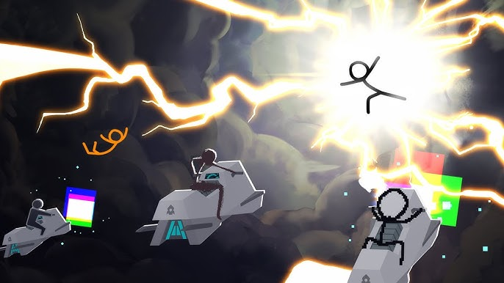

GATES OF HALLOWNEST – A Hollow Knight Animation by CybeR
https://www.youtube.com/watch?v=xZOzVq7X-b8


You’re Gonna Go Far Kid – OC AMV by Louixie
https://www.youtube.com/watch?v=gywHe8umRpk
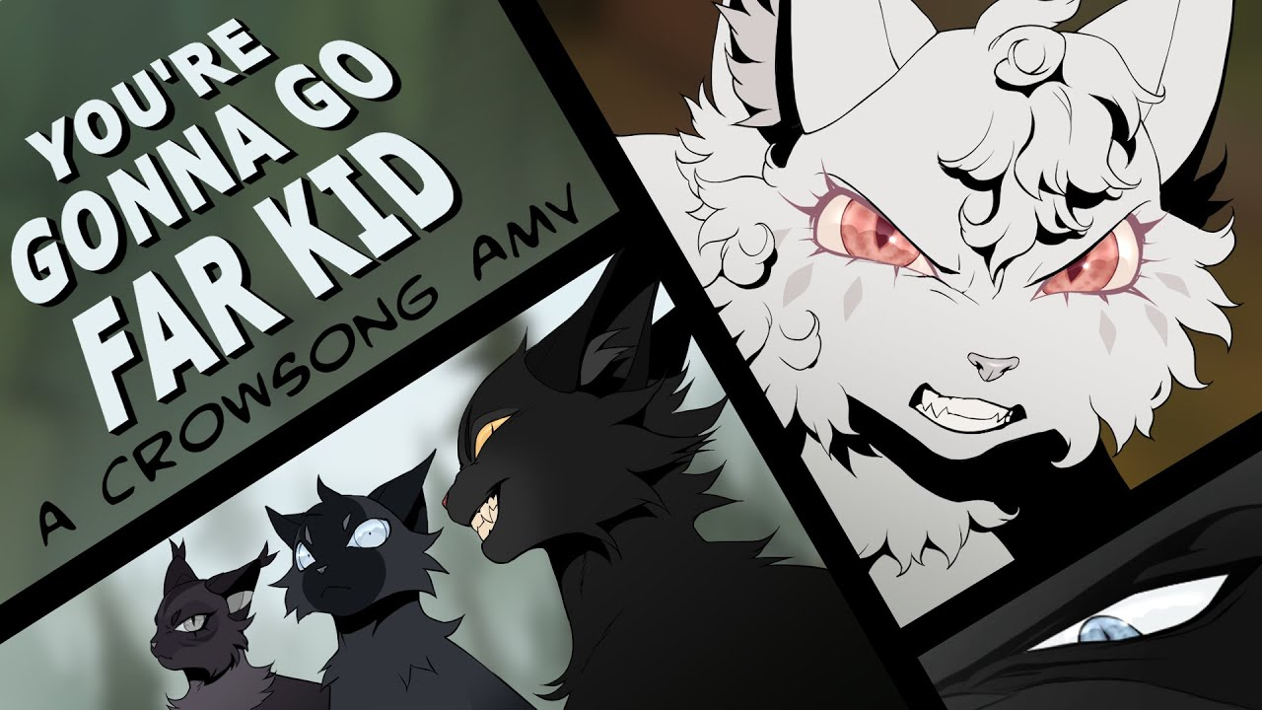

Avatar Element Animation 2 by Jared Koh
https://www.youtube.com/watch?v=T5vdPy7nbRQ
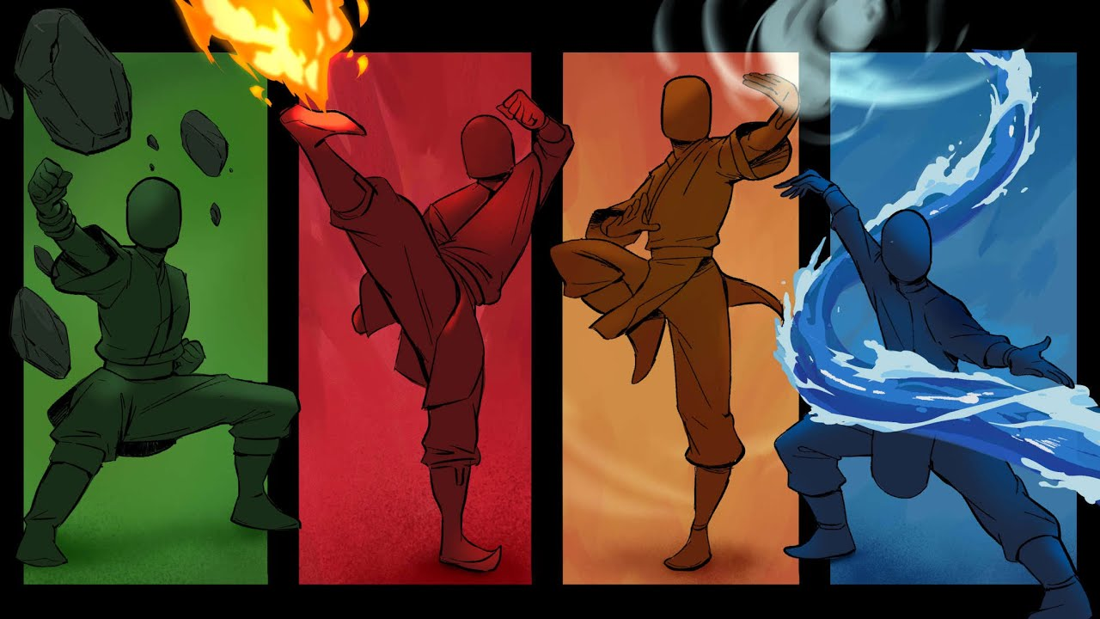

Spider-man: Across the Spiderverse - Shot Compilation by Amazing Shots
https://www.youtube.com/watch?v=EEXG0HNvsLw
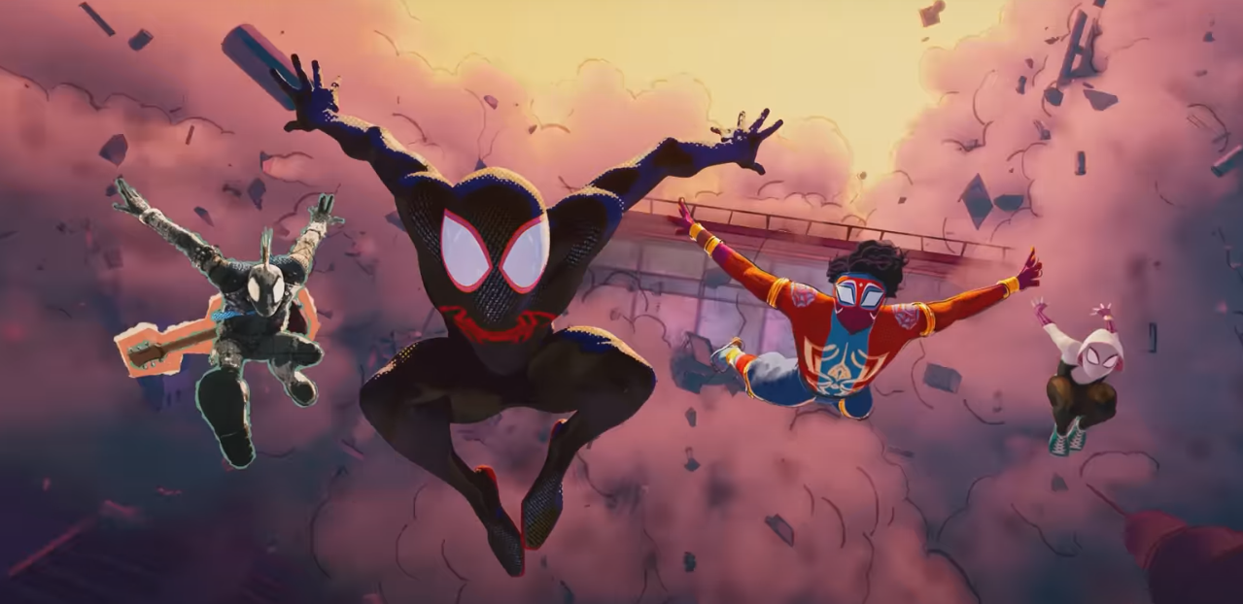

AI Documentation Queries
(Sorry po sir but links to the queries can’t be accessed aside from the user account in ChatGPT, here are screenshots in the meantime po)

Altering opacity while hovering query
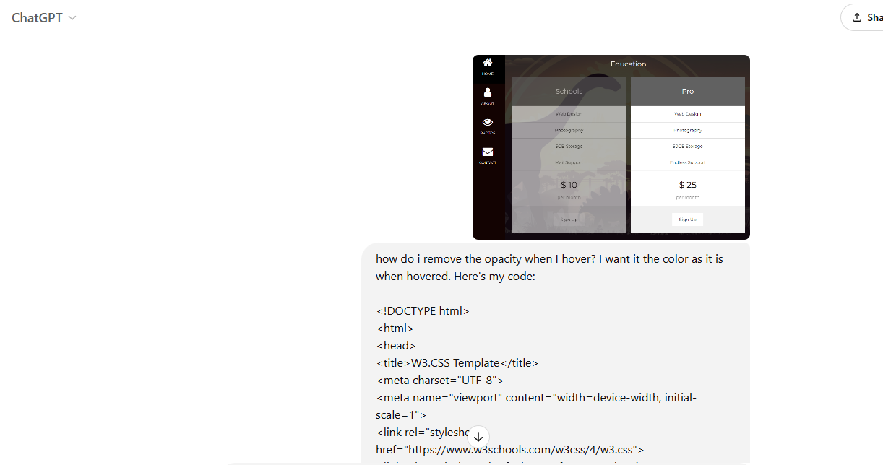
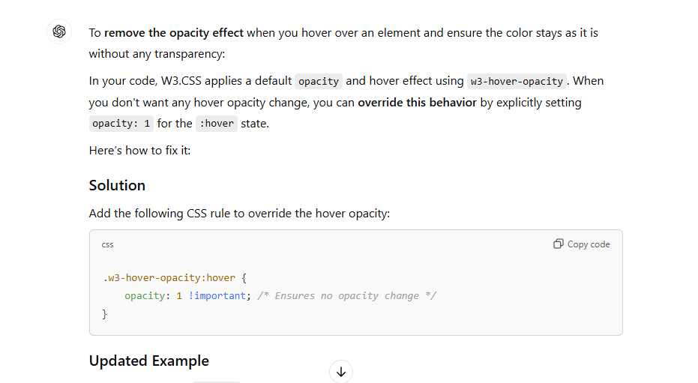

Fixing flexbox positions query (AI didn’t help much here)
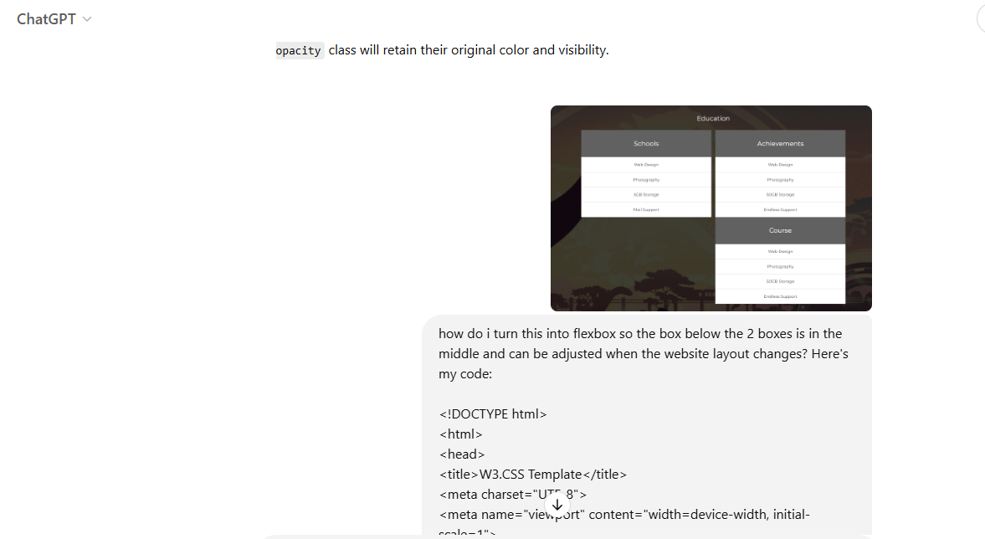
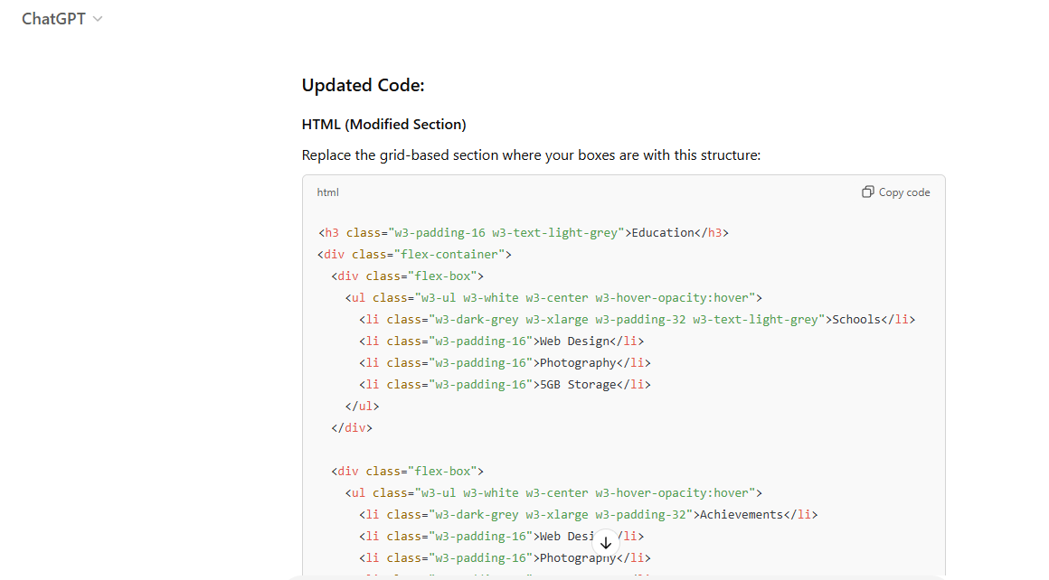

Vue Code Conversion Assistance Query
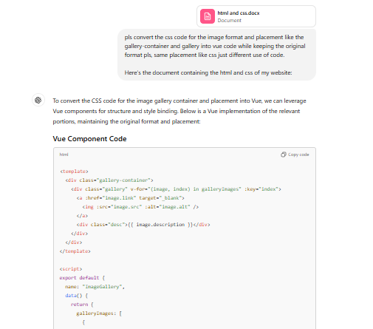
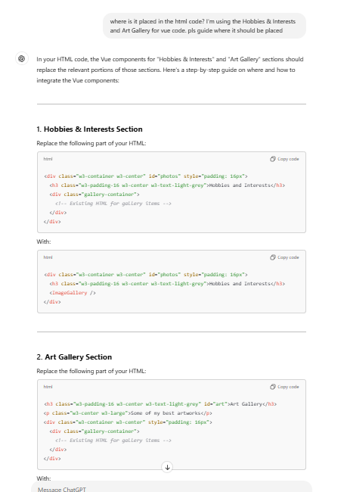
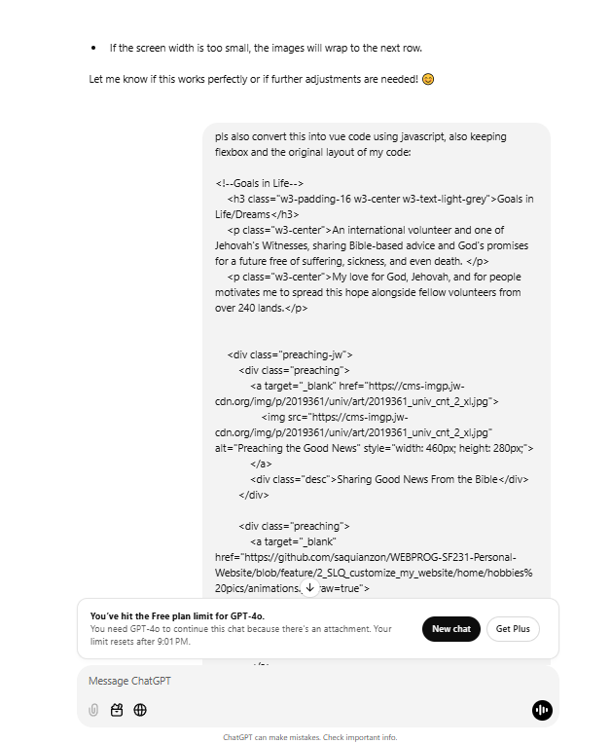
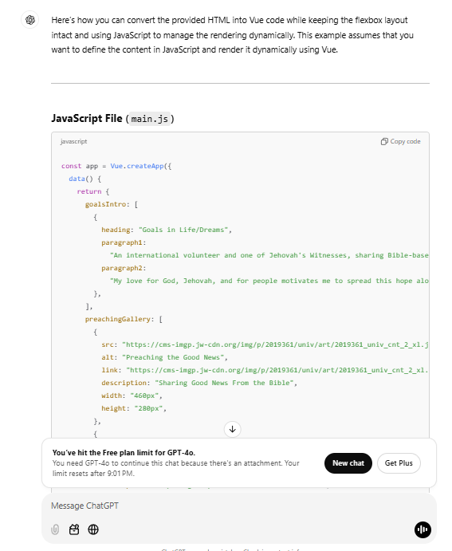
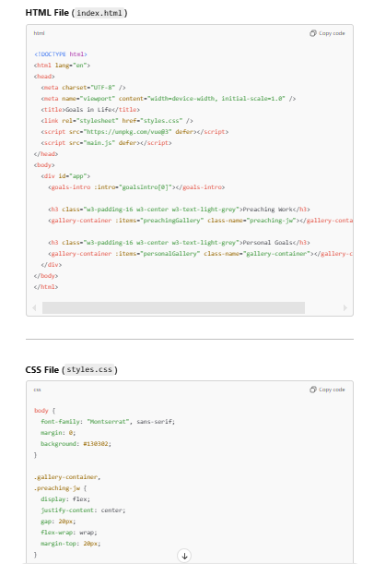

Quiz Assistance Query (I couldn’t find the chat where the AI provided a sample quiz in JavaScript)
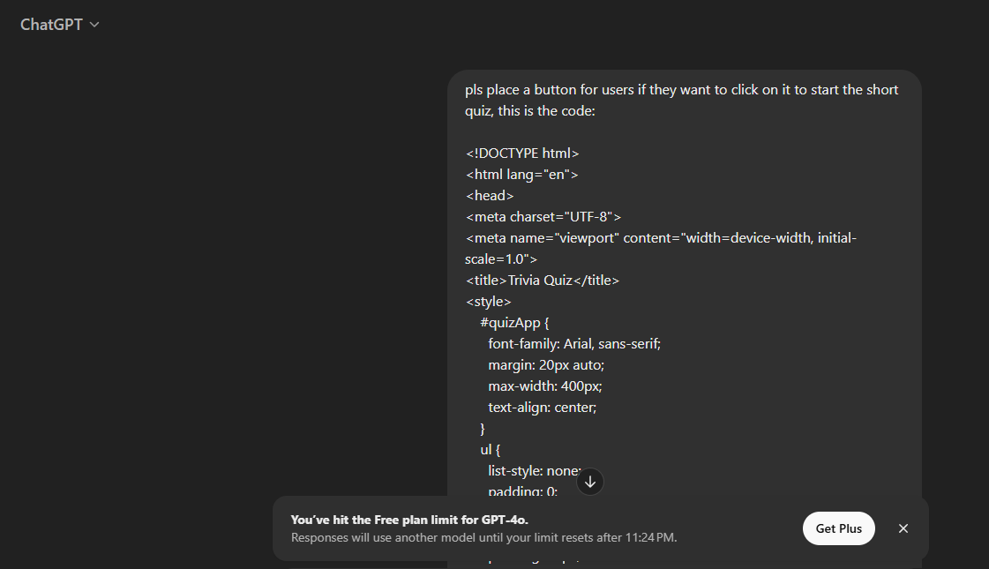
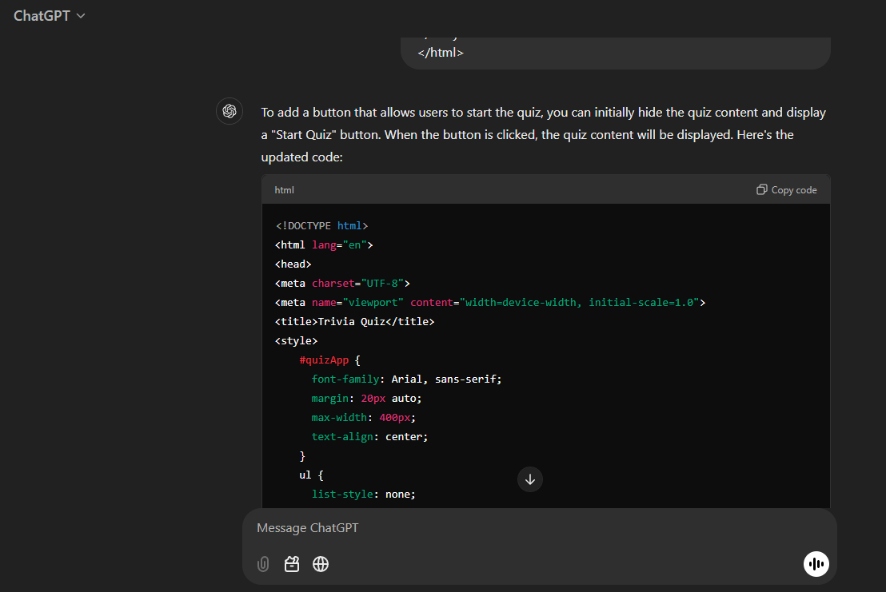
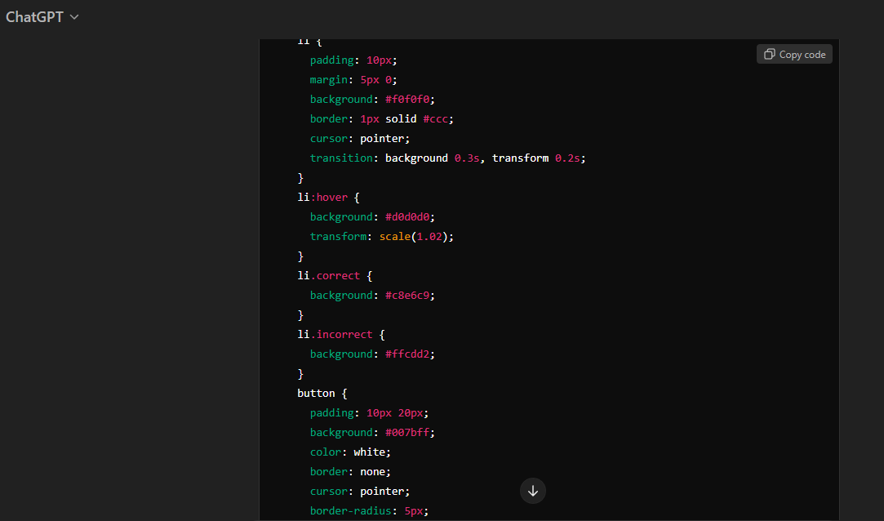

Survey Feedback – Vue Code Query
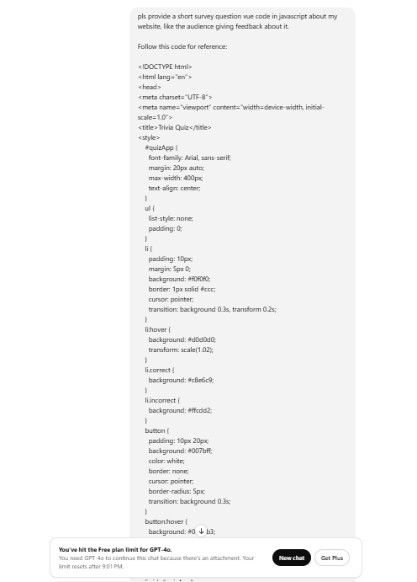
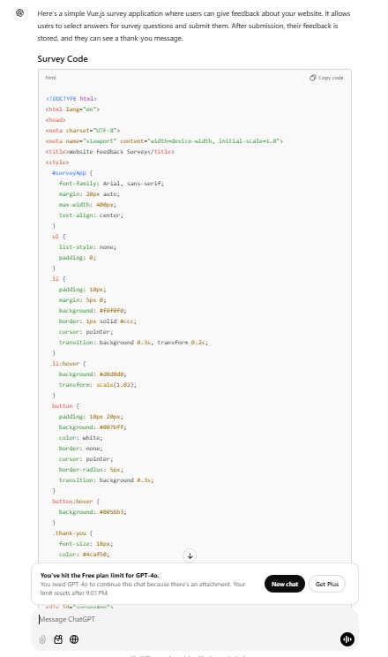
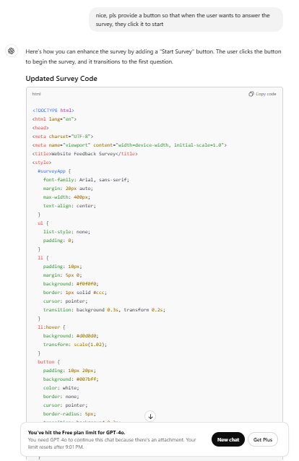

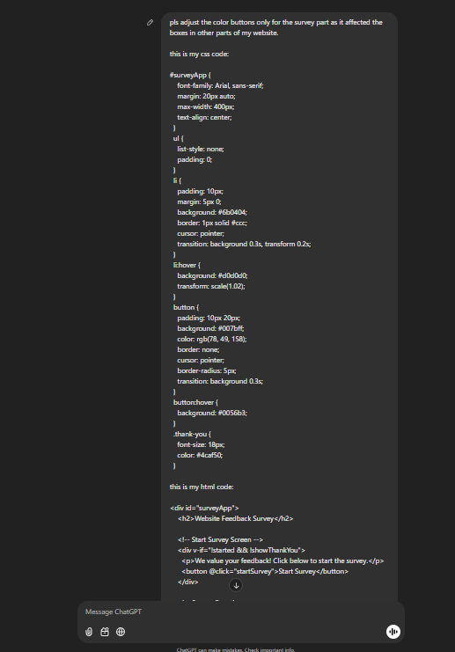
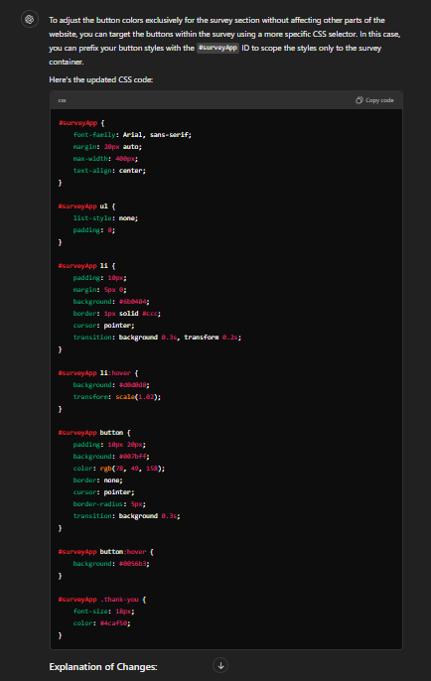

Vue Component Removal Query
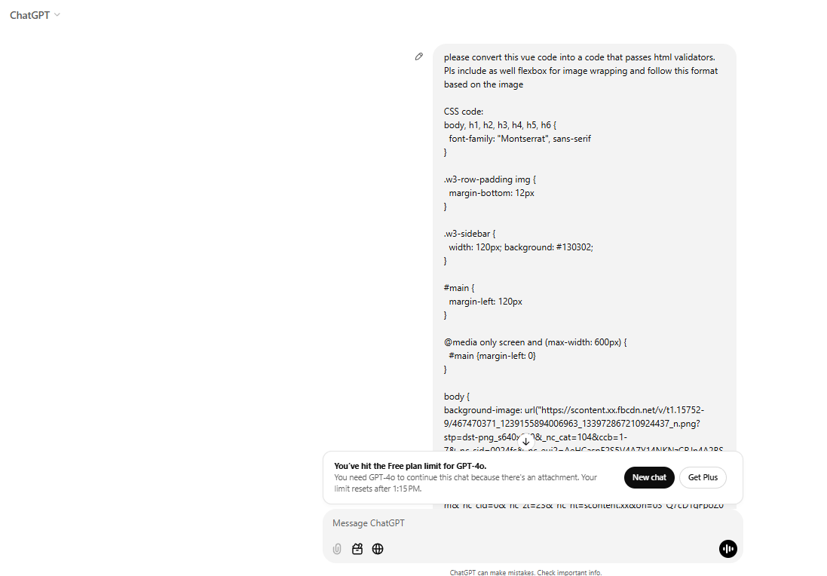
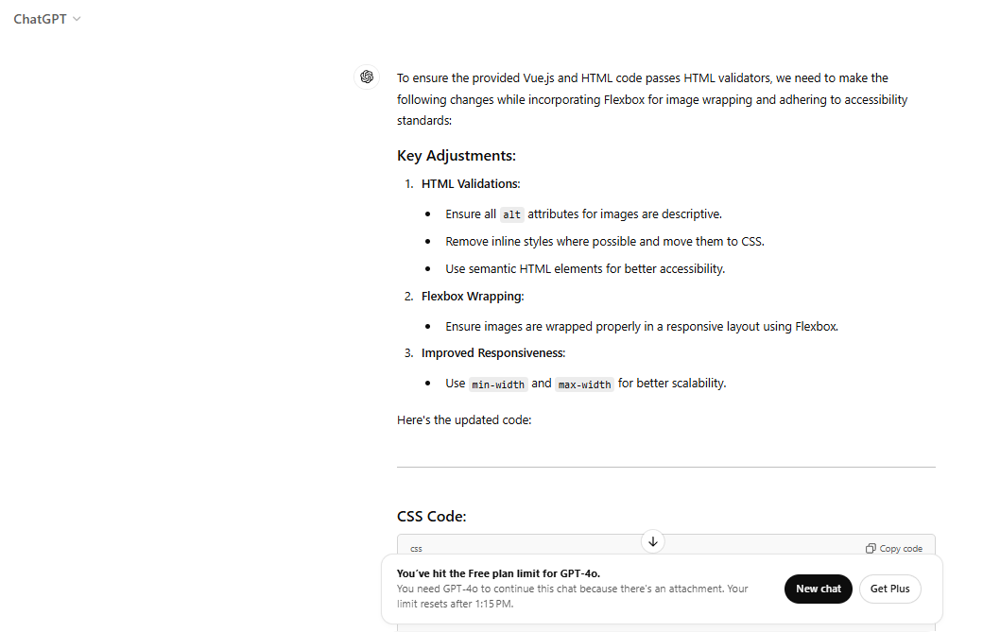
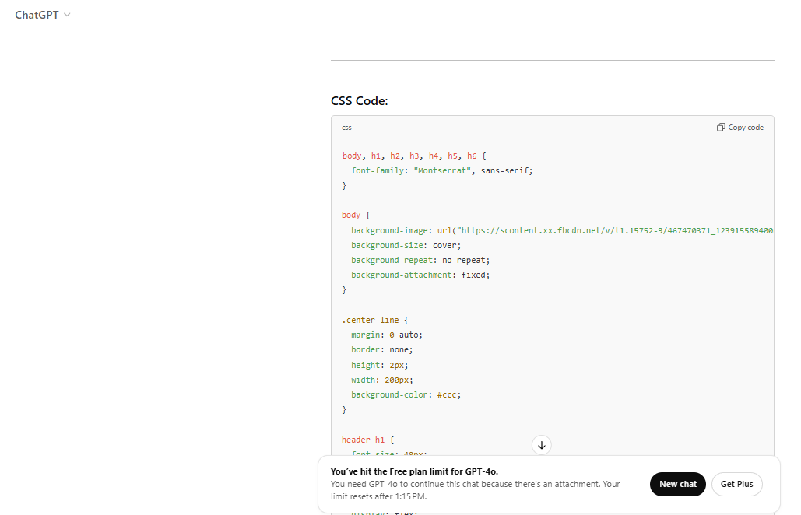
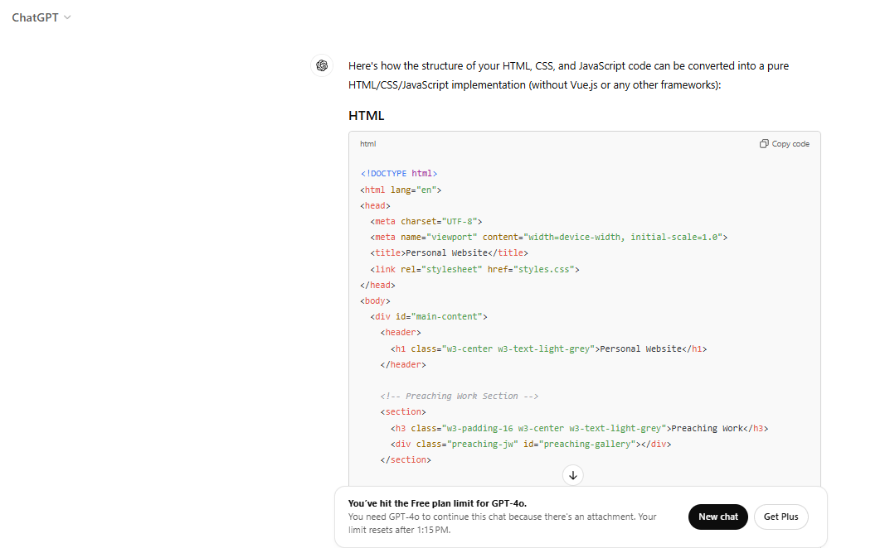
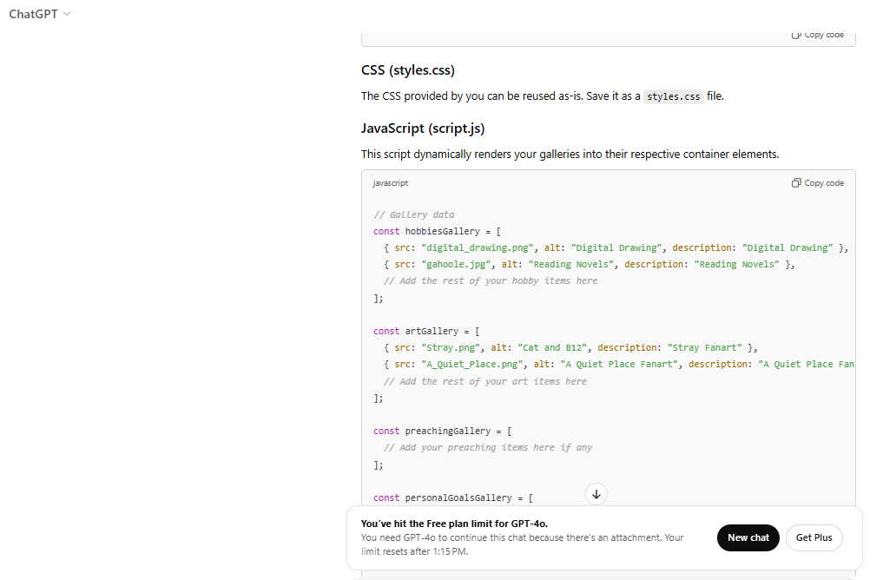
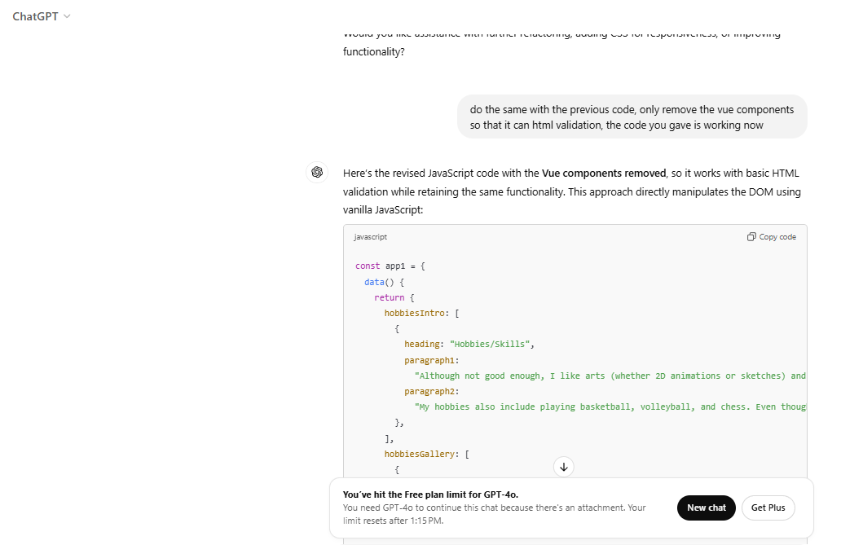
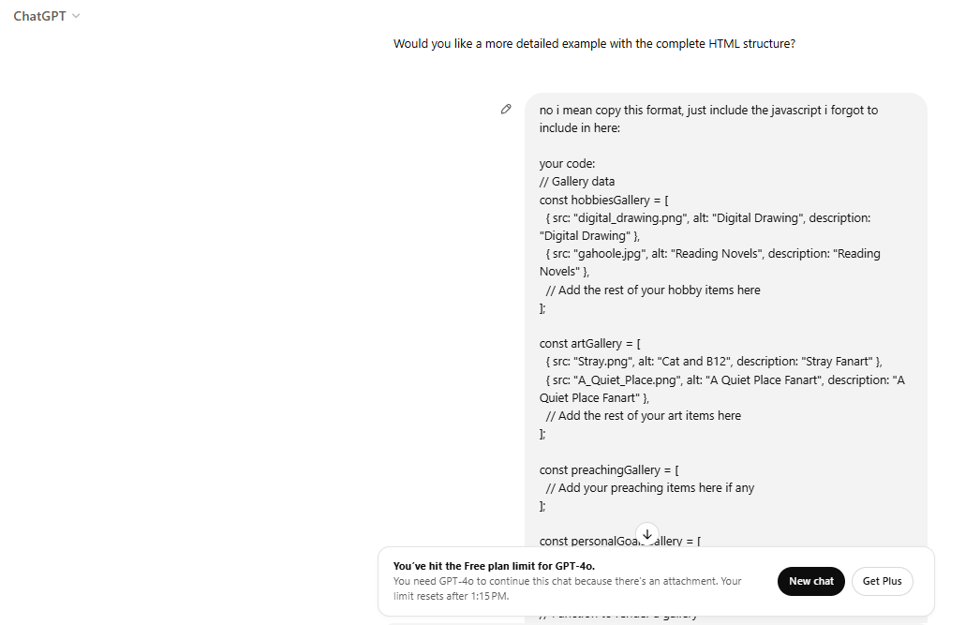
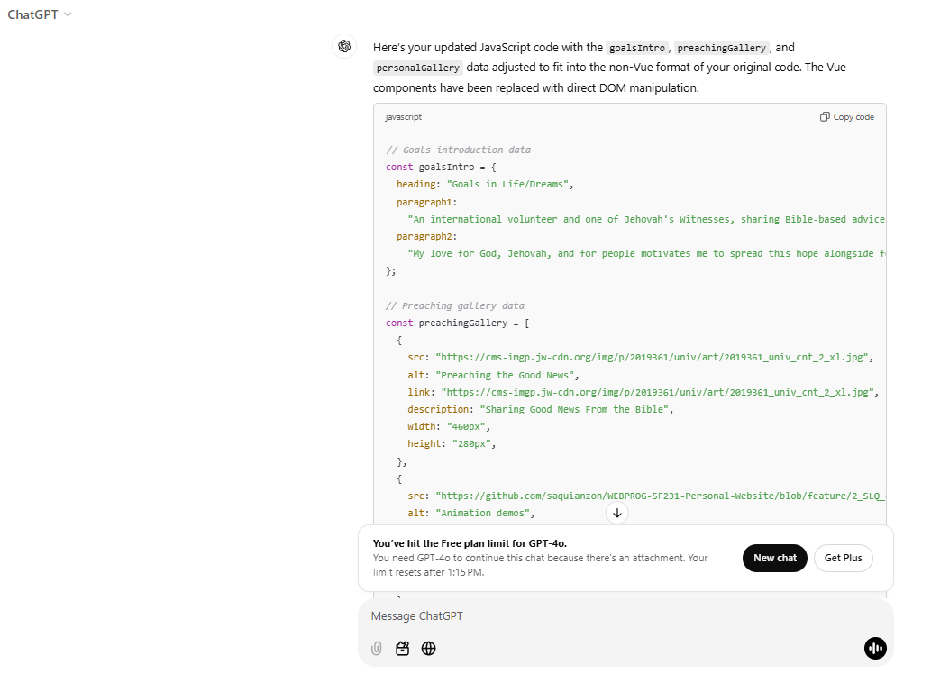
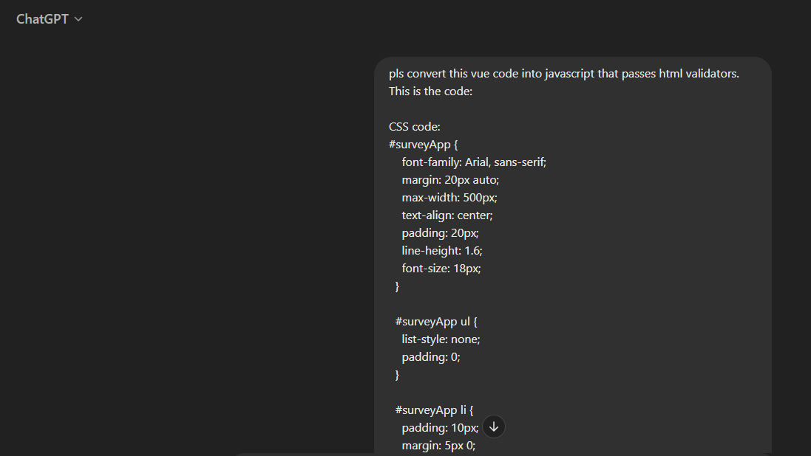
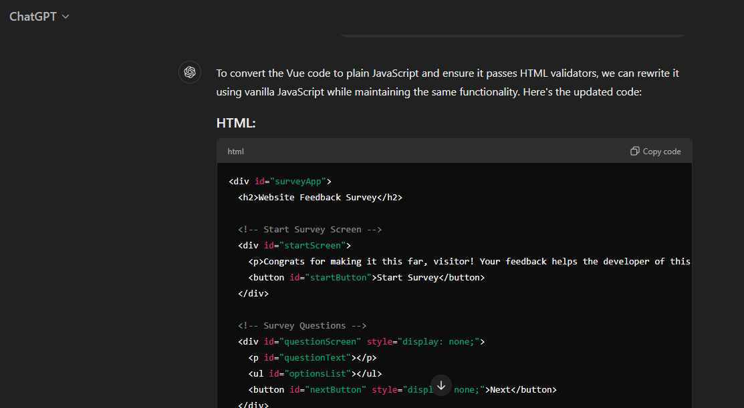
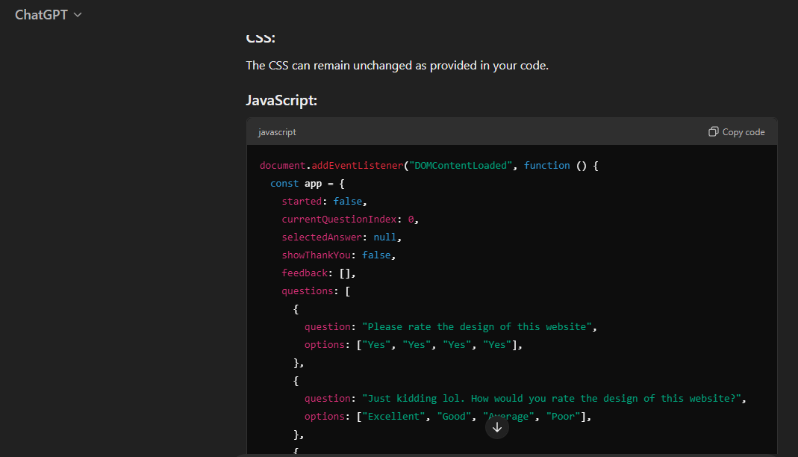
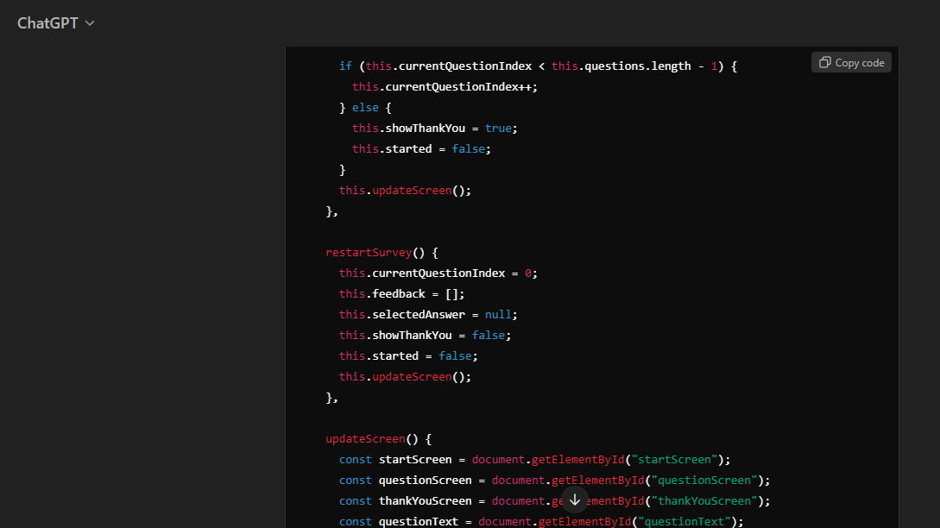

Adding Comment Section
